About the Dragon Dance Puppet
By Kay Cochran
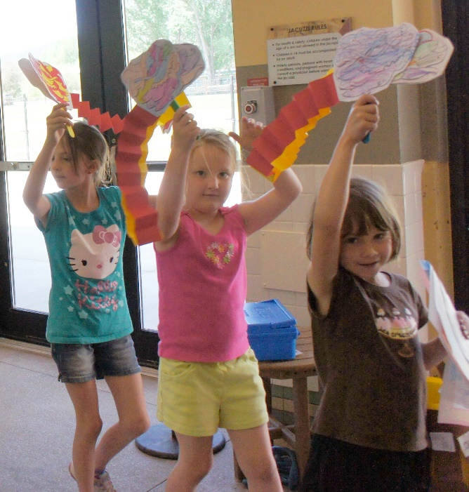
Dragon dance and lion dance puppets of all sizes are part of many celebrations. They can be seen in the streets during the Spring Festival (sometime called Chinese New Year) celebrations in many places around the world. The Spring Festival goes back over 4000 years. The whole festival lasts 15 days ends with the Lantern Festival. It is a celebration of family, tradition and culture, ancient but always changing.
In the West this is being written in the year 2020, a year that started on January first. The Spring Festival is based on a lunar calendar, so the date changes a bit each year. The New Year started on Jan 25th of 2020. If you counted in the traditional calendar the year isn’t 2020 but 4718. Each year has an animal associated with it, 4718/2020 is the Year of the Rat.
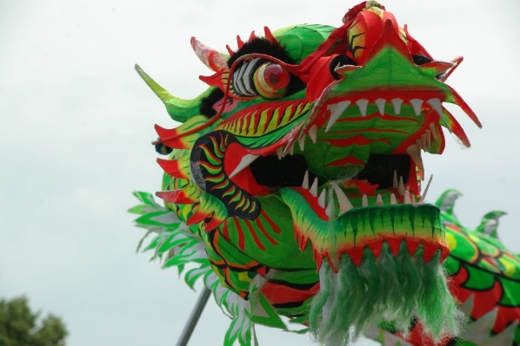
Unfortunately, this is being written about a month after the COVID-19 pandemic has started seriously affecting the United State. The effect is worldwide. In China, COVID-19 stuck during the Spring Festival travel season (similar to the Christmas travel season in the West). Many people were not able to see their families as they hoped this year. Hopefully the celebrations next year will resume and large public celebrations complete with Dragon Dances will fill the streets.
Little Dragon Dances can be celebrated. Small puppets usually dance in the hands of onlookers while the highly trained teams that run the big Dragon puppets and Lion puppets dance in the streets. Create your own Dragon Dance Puppet and celebrate family and friends.

